|  |  |
| --- | --- |
|  |  |

Faculty of Technology and Engineering

# DEPSTAR

**Department of Computer Science & Engineering**

Date:30/01/2025

# Practical 1

|  |  |  |  |  |  |
| --- | --- | --- | --- | --- | --- |
| Academic Year | : | 2024-25 | Semester | : | 4th |
| Course code | : | CSE208 | Course name | : | Operating System |

**Perform Linux Commands for the following.**

1. Practical 1: Exploring Linux Commands Through Real-World Scenarios Scenario: Organizing Course Materials for CSE Students

You are a 4th-semester CSE student managing your course materials for the subject Operating Systems (CSE208). Complete the following tasks step-by-step to organize your files and directories using Linux commands.

1. **Directory-Oriented Commands (Task: Set up the directory structure for your coursework.)**
2. **Create a directory named 4CSE to represent your semester**
   * **Command – Description**

**Command :** mkdir 4CSE

**Description :** The “mkdir” command can create multiple directories at once as

well as set the permissions for the directories.

**Syntax :** mkdir [options…] [directory_name]

* + **Implementation Screenshot**



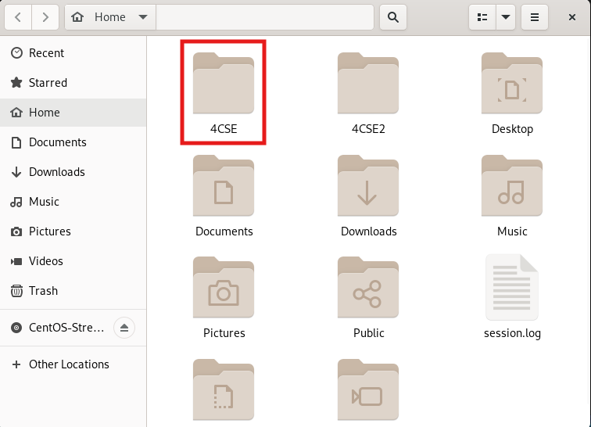

1. **Navigate into the 4CSE directory.**
   * **Command – Description**

**Command :** cd 4CSE

**Description :** The “cd” command allows you to change directories in CentOS.

making it easier to navigate through the file system and manage

your files efficiently.

**Syntax :** cd [directory_name OR directory path]

* + **Implementation Screenshot**



1. **Create subdirectories for organizing your subjects: CSE208_OS and CSE209_Python.**
   * **Command – Description**
   * **Implementation Screenshot**

|  |
| --- |
| **4. Verify the structure by listing all files and directories.**  **5. Check your current directory path** |
| **2. File-Oriented Commands(Task: Create and manage files for your coursework.)** |
| **3. File Processing Commands (Task: Process the content of your files.)** |
| **4. General Purpose Commands(Task: Use general-purpose commands to manage your session.)** |

Grade/Marks Sign of Lab Teacher with Date

**( / 10)**